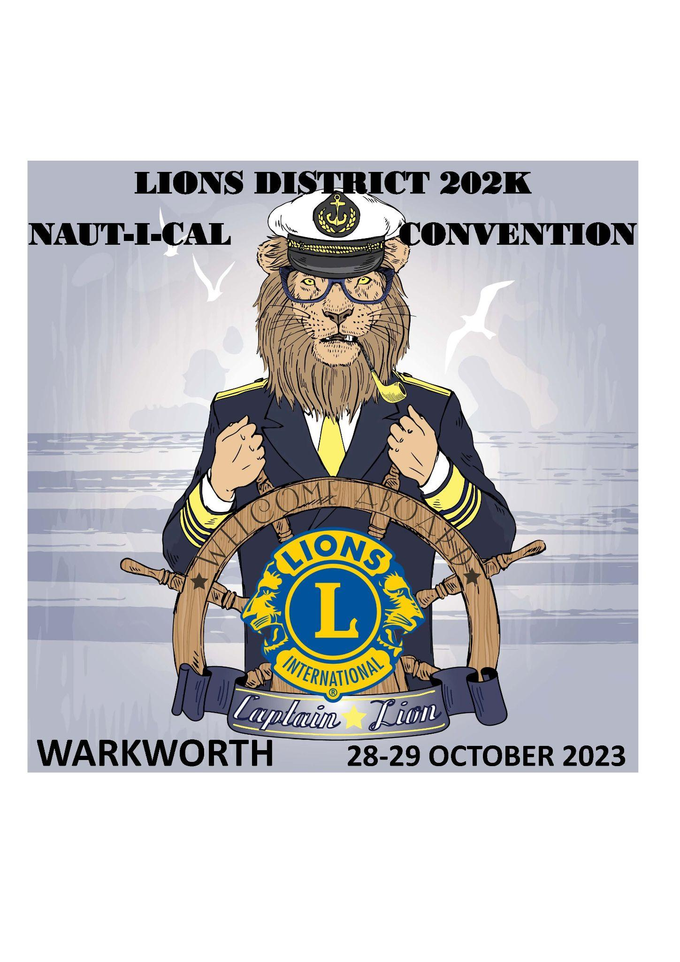
Plans are well underway for our 2023 Convention on the weekend of the 27th - 29th of October 2023.
We invite you to join us as we celebrate our Naut-i-cal Theme.
We start on Friday the 27th of October at the Bridge House Warkworth with an informal drinks function giving you an opportunity to catch up with old friends and meet new ones. You can also register while at the Bridge House with registrations open from 4pm to 7pm that evening.
The Convention will finish at 12pm on Sunday 29th of October after the Service.
We invite you to book your accommodation now in anticipation of the registration forms becoming available in early August.
Accommodation Options
There are some brilliant places to lay your head while in our small town with accommodation being set aside for Lions at the Bridgehouse in Warkworth, Matakana Motel in Matakana and the Salty Dog in Snells Beach. All locations are handy to each other and there are so many things to do in the local area – you won’t want to leave. Transport to and from the Saturday night function will be provided by vans with a koha from passengers.
Book your accommodation now as October is a popular time of year for visitors in our region. Let the accommodation providers know you are booking as Lions.
The Bridgehouse in Warkworth is a piece of local history which was most recently modernised in 2016. Set in Warkworth it has a central location for our events and an is an easy walk to the convention location at Mahurangi College.

Book at:
http://www.bridgehouse.co.nz/accommodation-warkworth

Matakana Motel is set in the heart of Matakana village close to the local Matakana Markets and Morris and James Pottery. Matakana is about 8.9km out of Warkworth.
Book at: https://www.matakanamotel.co.nz/rates

Salty Dog Inn in Snells Beach is 8 km out of Warkworth and is a small town near local beaches. It is close to the Brick Bay Vineyard/Restaurant and Sculpture walk, regional parks and the Sandspit wharf where you can catch the Ferry to Kawau Island.

Book at: https://saltydog.nz/accommodation/

To stay up to date with updates for the convention please sign up to our mailing list here.

