 | 202J District Convention  5th – 7th April 2024  Hosted by Lions Club of Ashburton  Venue: Hotel Ashburton,  Racecourse Road, Ashburton  REGISTRATION FORM | 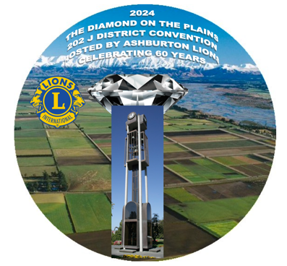
Note: An online version of this form is available
- Click download to be able to type.  - Or Print and hand write your details. | - Then print, scan, and send to: 202j.convention@lionsclubs.org.nz
IMPORTANT: Each PERSON must complete a separate registration form (please print clearly)
Surname |  |  |  |  |  |  |  | First Name
Club |  |  |  |  |  |  |  | District
Lion |  |  |  | Leo |  |  |  | Office Held
Partner’s Surname |  |  |  |  |  |  |  | First Name
Postal Address
 |  |  |  |  |  |  |  |  |  | Post Code
Email |  |  |  |  |  |  |  |  |  | Phone
REGISTRATION AND FUNCTIONS |  |  |  |  |  |  |  |  |  | COST($) |  | LION | PARTNER |  | TOTAL($)
Convention Registration: Lion (Compulsory/non-refundable) |  |  |  |  |  |  |  |  |  | 25.00 |  |  | N/A
Convention Registration: Non-Lion Partner  (Compulsory/non-refundable) |  |  |  |  |  |  |  |  |  | 25.00 |  | N/A
Friday Night Meet & Greet + Supper |  |  |  |  |  |  |  |  |  | 10.00
Saturday Morning tea and lunch |  |  |  |  |  |  |  |  |  | 30.00
Partner’s Tour includes Morning tea and lunch |  |  |  |  |  |  |  |  |  | 30.00
Saturday Evening meal, entertainment and live music  Theme: Diamonds and Denim |  |  |  |  |  |  |  |  |  | 70.00
Sunday Rededication/Remembrance Service with light lunch |  |  |  |  |  |  |  |  |  | 25.00
Late registration fee (after 22nd to 29th March 2024) |  |  |  |  |  |  |  |  |  | 20.00
TOTAL TO PAY $
Dietary Requirements
Gluten Free |  |  |  |  | Vegetarian |  |  |  | Dairy Free |  |  | Other |  | ?
REGISTRATION & PAYMENT OPTIONS REGISTRATIONS CLOSE 21st March 2024
Payment is by way of Internet Banking please.
NBS Internet Banking Details: | Account Name: Ashburton Lions Convention AC
 | Account Number: 03-1354-0644342-00
Particulars: Member’s Name; Code: Club Name; Reference: Registration
Date Internet Banking Completed: ___/___/______ (D/M/Y)
(Registrations will be confirmed once the internet banking is received)
EMAIL: Attach your scanned form and send to: 202j.convention@lionsclubs.org.nz
POST: Registrations, Lions 202J Convention, C/- Graham Smith, 64 Elizabeth Street, Ashburton,7700

