DG John Whyte & Marianne
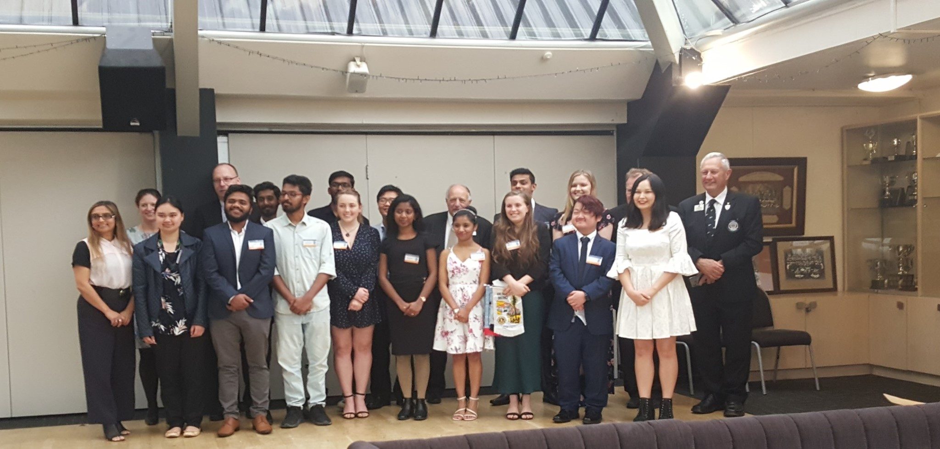

Canterbury Omega Leo Club Charter night
Global Causes
Diabetes
Vision
Hunger
Environment
Childhood Cancer

4th December 2019 Over 70’s Christmas Dinner Kaikoura Lions
8th December 2019 War Memorial unveiling Woodend Lions
14th December Senior Citizens Xmas party Amberley Lions
27th December 19 Big Dig Amberley Lions 19th January 2020 Fishing competition Amberley Lions
6th – 8th March 20 District E Convention Rangiora
11th April 20, Akaroa & Bays Lions Paddy’s Market
1-3rd May 2020 Whangarei Multiple Convention
26-30 June 2020 Singapore International Convention

Contents
Page 1. Cover
Page 2. Contents and Diary
Page 3. New members and Bereavements
Page 4, DG Message
Page 5. Club activities & Personal Development
Page 6. Camp Quality
Page 7. Camp Quality Roster
Page 8. Youth Exchange & club Activities
Page 9. Clubs & Music Festival
Page 10. Music Festival
Page 11. Club Activities
Page 12. Convention
Page 13. Convention
Page 14 Convention
Page 15. Convention
Page 16. Convention
Page 17. Convention
Page 18. Host club 60th anniversary
Page 19. Club Activities
Page 20. Club Activities
Page 21. Motorhoming Lions Club
Page 22. Thank you to firefighters
Page 23. Convention important info
Page 24. Editor

Bereavements October 2019
NEW MEMBER CLUB SPONSOR
PAUL REESE AMBERLEY PAM HARVEY
RICHARD OSMASTON GREYMOUTH PETER JENKINSON
JENNETH JANE GADOPP HAWARDEN WAIKARI
PETRUS RAUTENBACH HOKITIKA CHARLES COWIE
SIRITA RAUTENBACH HOKITIKA CHARLIES COWIE
LUANA CATTON SEAWARD MAUREEN HAMMOND
WAYNE MATTHEWS OXFORD THEO FERREIRA
NEIL CHRISTIE PICTON NORMAN GAMBLE
JOE LARRINGTON PICTON CAROLYN EDWARDS
RAVI SAINI PICTON MURRAY CHRISTIE

Welcome to our New Members
For October 2019
JUDITH MACDONALD BEAVERTOWN
RON MOORE BLENHEIM
FOSTER RUDD BLENHEIN PAKEKE
LLOYD JOHNSTON KAIKOURA Charter President KK Lions
DAVID WILSON MOTUEKA
ROBIN JOHNSTON OXFORD

DG John’s message
Today the 1st Dec 2019 I called a special meeting of the cabinet and the International Officers of our district to appoint a 2nd Vice District Governor and I would like to announce that Tracy Henderson has been appointed for the rest of this year. Congratulations Tracy, I look forward to working with you.
It has been a very busy time for Marianne and I with a lot happening in our District since my last report. We are grateful for the hospitality that our Lions clubs are showing us as we continue to make our way around the District. Also, I would like to thank those Rangiora members who have travelled with to visit the clubs, I know they are amazed at what clubs are doing and the fellowship they encounter, when Marianne hasn’t been able to come with me. We enjoy hearing what clubs are doing in their communities and what activities they have under way. This is a busy time for a lot of clubs, so please be careful out there.
At one club visit this month a club has donated $1,000 to LCIF for the Australian bush fires. Remember when you are giving donation’s to LCIF please let John Benefield know and make sure that you get this tagged towards a Melvin Jones award that can use later.
Last week I helped induct 3 new members at the Malvern club and then the following night I was at the Oxford club and they had one new member and I inducted Tracy Henderson’s partner, George into our New Zealand Motor Home Lions club. This club is a club branch of the Blenheim Lions Club.
Also, on the 10 November the district chartered our first Omega Leos Club in Christchurch, this club is known as Canterbury Omega Leos Club. That was a very successful afternoon.
Congratulations and welcome to all new members.
We would like to take this opportunity to wish all Lions and families in District 202E a Merry Christmas and a safe and Happy New Year.
We look forward to working with you in 2020 in our communities as “We Serve by Loving, Kindness and Diversity.
District Governor John and Marianne Whyte

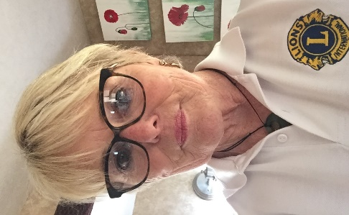
Introducing 2nd VDG Tracy Henderson
Congratulations Tracy, all the best as you serve our District for rest of this fiscal year.

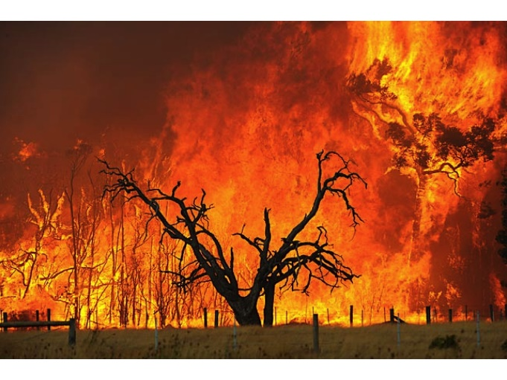
AUSSIE BUSH FIRES
Clubs have received the full information on this huge disaster.
It is suggested that all Clubs pay any monies through LCIF as normal - see the notes below so you can make sure the money gets to the Australian Bushfire Disaster AND gain MJF credits for your Club at the same time.
Any payment direct to the Australian Lions Foundation will get to the Australian Lions Clubs BUT with no benefit to your Club as far as Melvin Jones Fellow award credits are concerned.
Please pay online and make sure your CLUB NUMBER is entered as a reference, along with LCIF MJF.
Send an email to John Benefield at Johnnyb49@outlook.co.nz so he can make sure it is reconciled to your Club record as our District LCIF coordinator.
If you are still paying by cheque, take it to the bank and ensure the CLUB NUMBER is entered and the club name on the deposit slip along with LCIF MJF. If there is space, enter AUST FIRES or AUST DISASTER.
Again send an email to John Benefield at Johnnyb49@outlook.co.nz so he can make sure it is reconciled to your Club record as our District LCIF coordinator
Personal Development
The following opportunities are available to Lions in our District:
1 Pathways to Leadership [the title is self-explanatory]. This is for floor members up to President.
- Open to Lions in the South Island [Districts 202 E, J and F]
- To be held in our District [venue to be decided]
- 25 January 2020
- Leadership explained and explored… and how you get there.
2 ELLI [Emerging Lions Leadership Institute]. This is for floor members up to President.
- Christchurch
- 17 – 19 April 2020
- A good starter course for those who want to understand the organisation and do some skill training.
3 Certified Guiding Lion Courses
- Christchurch, 22 February 2020
- Blenheim, 29 February 2020
- Open to any Lion
The Certified Guiding Lion Programme is designed to assist both newly chartered and established clubs to work more efficiently, identify issues and work towards addressing them. Guiding Lions are appointed by the District Governor.
This programme will help participants
- Understand their role as a Guiding Lion
- Develop a plan to guide the club to becoming more efficient and stronger.
- Provide the tools to help officers manage their club.
- Establish a system to track development.
For more information go to Resources on the Lions International website
These are all well-structured courses with knowledge and skills that can be used in all walks of life – personal and business.
If you are interested or know of members who could benefit themselves and our organisation please contact
PDG Peter Gamble
peter.gamble@lionsclubs.org.nz 021 1688 194

Camp Quality New Zealand
Measles Procedure
from Dr John Fleming (Camp Quality New Zealand Medical Advisor)
20 October 2010

ATTENDANCE AT CAMP
- All campers*, companions and volunteers attending Camps must have a history of being immunised against measles
- Anyone who is unimmunised must not attend Camp
* Note this also applies to siblings of Campers

DETERMINING IMMUNISATION STATUS
- The MMR vaccine is routinely given at 15 months and 4 year of age
- ii. Catch-up immunisations for those not immunised in early childhood is effective and involves two doses of MMR vaccine given at least four weeks apart
- iii. Adults born before 1969 are considered to be immune and are exempt from immunisation requirements
Additional Resources: https://www.health.govt.nz/your-health/conditions-and-treatments/diseasesand-illnesses/measles
 | Sunday  January  12​^{th} | Monday  January  13​^{th} | Tuesday  January  14​^{th} | Wednesda  January  15​^{th} | Thursday January  16​^{th} | Friday January  17​^{th}
Breakfast |  | 8.00am Service  Wigram (!0) | 7.45am Service Chch South  Halswell | 8.00am Service  Ellesmere  New Brighton | 8.00am Service  Rangiora  Chch Host | 8.30am Service Ferrymead  Selwyn
Lunch | 12.30pm Service  Seaward KK  Amberley | 12.30pm Service Pegasus  Chch North | 12.30pm Service Malvern  @ Spencer Park
Dinner | 5.30pm Service  Amuri (7) | 5.30pm Service  Seaview  Oxford | 5.30pm Service  Akaroa  Chch Breakfast | 5.30pm Service  Riccarton/Waimari  Glenmark | 5.30pm Service  Rolleston  Hawarden/Waikari

Hi Lions There are 12 clubs not returned Membership to Mylion. Those that have how are you going with reporting activities refer to YouTube video sent last month on how to Or contact me I can help. Most activities seem to be in the other category don’t worry that is the system we have? Sam Lilley
See these graphs – shows where we are at.
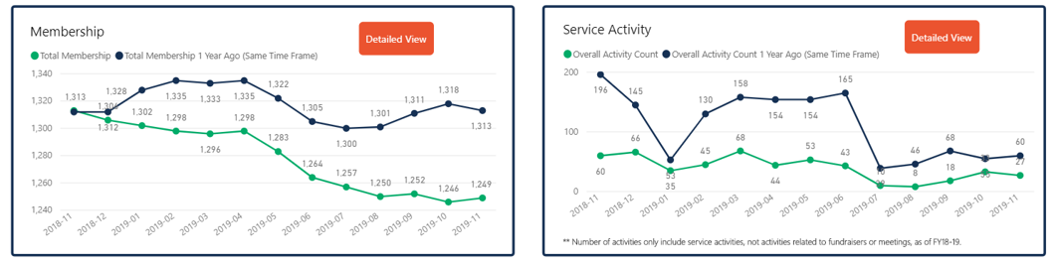

HOSTING YOUTH EXCHANGEES
I am looking for help please with hosting some International Youth Exchangees:
1 x Australian boy, aged 17years - for 16th to 26th December 2019
1 x Brazilian girl, aged 17 years - for 6th to 27th January 2020
1 x Brazilian boy, aged 19 years - for 6th to 27th January 2020
The Australian boy needs hosting before attending the international Youth Camp in Tauranga and the 2 Brazilians seek hosting after this camp.
Remember please that Clubs should support those who host students – a family may provide a bed but then it is good for others to assist with day activities.
Time is getting near so I do hope to have offers soon please for hosting. Thank you.
Sarah Flint
202e Youth Exchange
sarahflint60@gmail.com
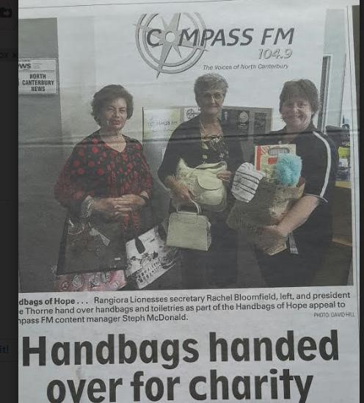
Rangiora Lioness
Toiletries and handbags handed over for charity.
Great publicity and great project.

Nelson Host Lions 35th Annual Charity Golf Tournament
On Sunday 10th November the annual golf tournament was held at the Nelson Golf Couse.
The weather did not look all that good with the rain radar showing rain for most of the day, but it was wrong with sunshine and warm weather showing its face shortly after 11 am.
Those that had played the tournament for all those years it was a great honour to have their presence on the day. Special thanks to all our sponsors and those that played.
The recipients of the money this year was Nelson Bays Diabetes a great cause, over the years a lot of money has been given to various charities this is in excess of $250,000, the club is extremely grateful of the support of the Nelson business and people for their ongoing support and look forward to the support in the next 35 years.
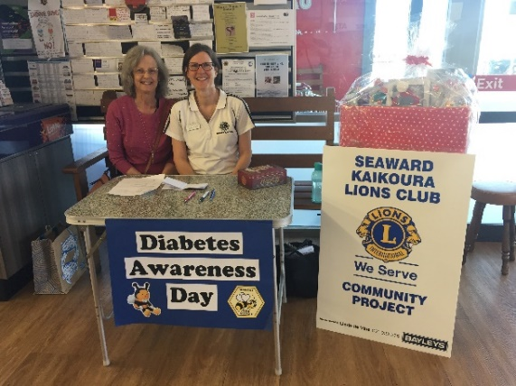
Seaward
Lions Judith Stevens and Sandra Wyatt manning the
Diabetes stand at New World where blood pressure and blood glucose testing were offered free to the community. The raffle proceeds went to Diabetes

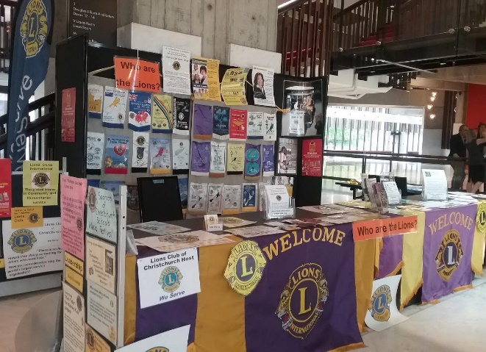
Lions Christchurch Schools Music Festival - 2019
“You’re the Voice”
They were “The Voice” of the 80th Schools Music Festival – an amazing blend of children’s voices, instrumental music, deaf singers, and the enthusiasm of thousands of young people. What an inspiration to all who attended the 4-night festival. I was able to attend on the first night, along with DG John and Marianne Whyte, and PDG Ian, to celebrate the return of the Festival to the Christchurch Town Hall for the first time since the earthquakes. It was great to see a young man who had been in the last festival in the Town Hall in 2010, then just a school boy who played the Double Base. Former Lion Liaison Wendy Workman and I were approached by his mother at that festival, asking us if Lions helped young people, as this talented young musician was to be in the Youth Orchestra, which meant travelling around the country, but he didn’t have a case for his instrument. I put him in touch with his local Lions Club, who provided the case. After the 2011 earthquake, he emailed me to say that although their home had been badly damaged his instrument was safe. That young man is still involved with the Festival, playing a variety of instruments where needed as a “guest” artist, but he also conducted the orchestra, and arranged one of their pieces, having now completed a music degree. That’s what this Festival can lead to.
I set up a comprehensive Lions display – the only major sponsor display at the venue, and attended every night to look after it, sell programmes, and “talk Lions” whenever I could. Although Lions have had naming rights for 20 years or more, we now have to apply each year, with this year our sponsorship having to increase from the $7000 we have paid over all those years to $10,000, and I anticipate that in order to keep the naming rights next year, we will be expected to put in even more – still good value for the exposure Lions get. As well as that display, which is up for the duration of the festival, so that parents and teachers and others who were at the Town Hall during the day for rehearsals could browse through the information there - and it was pleasing to see that many of the information brochures I had available had been taken away - the Lions symbol and name appeared frequently on the two large screens behind the stage, and we had frequent mention during the introduction to the various musical items. As well, the back page of the programme is a complete Lions advertisement, which I designed several years, and they have kept, updating contact details and the DG’s name each year.
Thank you to all Clubs who contributed to this amazing showcase of our young talent, and who stopped to say hello to me while I was on the stand. I hope to attend the Festival Association AGM early next year, to put the case for yet another year of Lions naming sponsorship of the Christchurch Schools Music Festival.

PDG Marion McWha – Schools Music Festival Lion Liaison Lions Past District Governor
Marion McWha
32 Quaids Road
Marshland
Christchurch, 8051

Thursday 31 October, 2019

Dear Marion,

This letter is an official letter of thanks to the Lions District Cabinet 202E for the increase in funding you were able to donate to us this year. It is very much appreciated. We were hoping that costs would be less when we returned to the Town Hall but the opposite is actually the reality, with many things that we used to have allocated as part of our rental nights all being charged for separately.

Thank you for the support which the Lions provided to help make the 2019 Music Festival season a success; it can never be said enough times that the on-going support for such community activities provided by service organisations such as yours is vital in making such events a reality in these increasingly commercial times.
We will continue to ensure that the Lions District Cabinet 202E features prominently in our advertising, programme and promotional material for the festival. The partnership between our association and yours is very important to us and we value your continued support. We would ask that you convey our sincere appreciation to your members.
Yours faithfully
Sharyn J Hay
Christchurch Schools Music Festival association Inc

If you can believe it, the mind can achieve it.” – Ronnie Lott
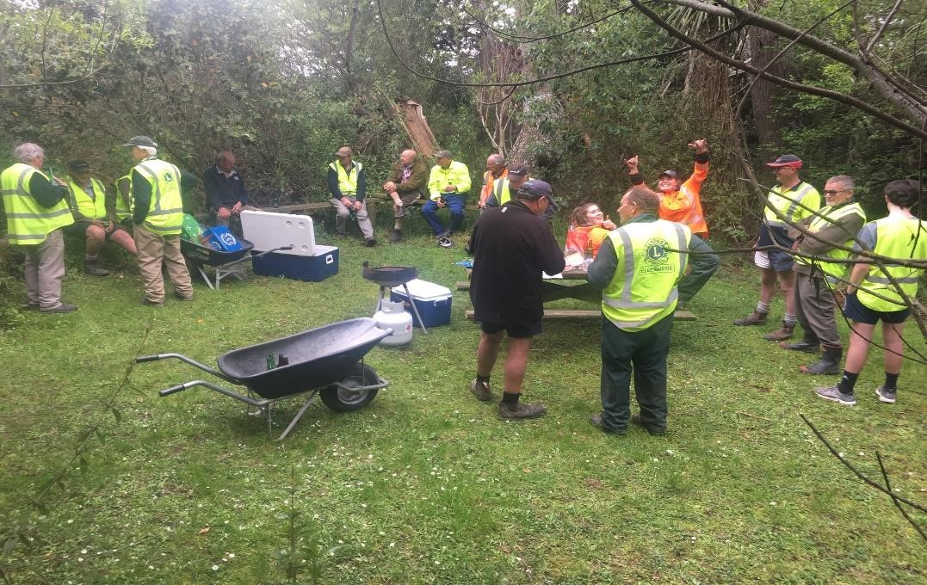
Ellesmere
Bird Hide – 15 members helped out at the working bee. The shingle was very
kindly donated by Sandy Shirtcliff, with good progress made, approximately
1/3rd of the track completed. It has been suggested that we shingle the rest
of the track to cut down on the expense and commitment of maintaining the track.

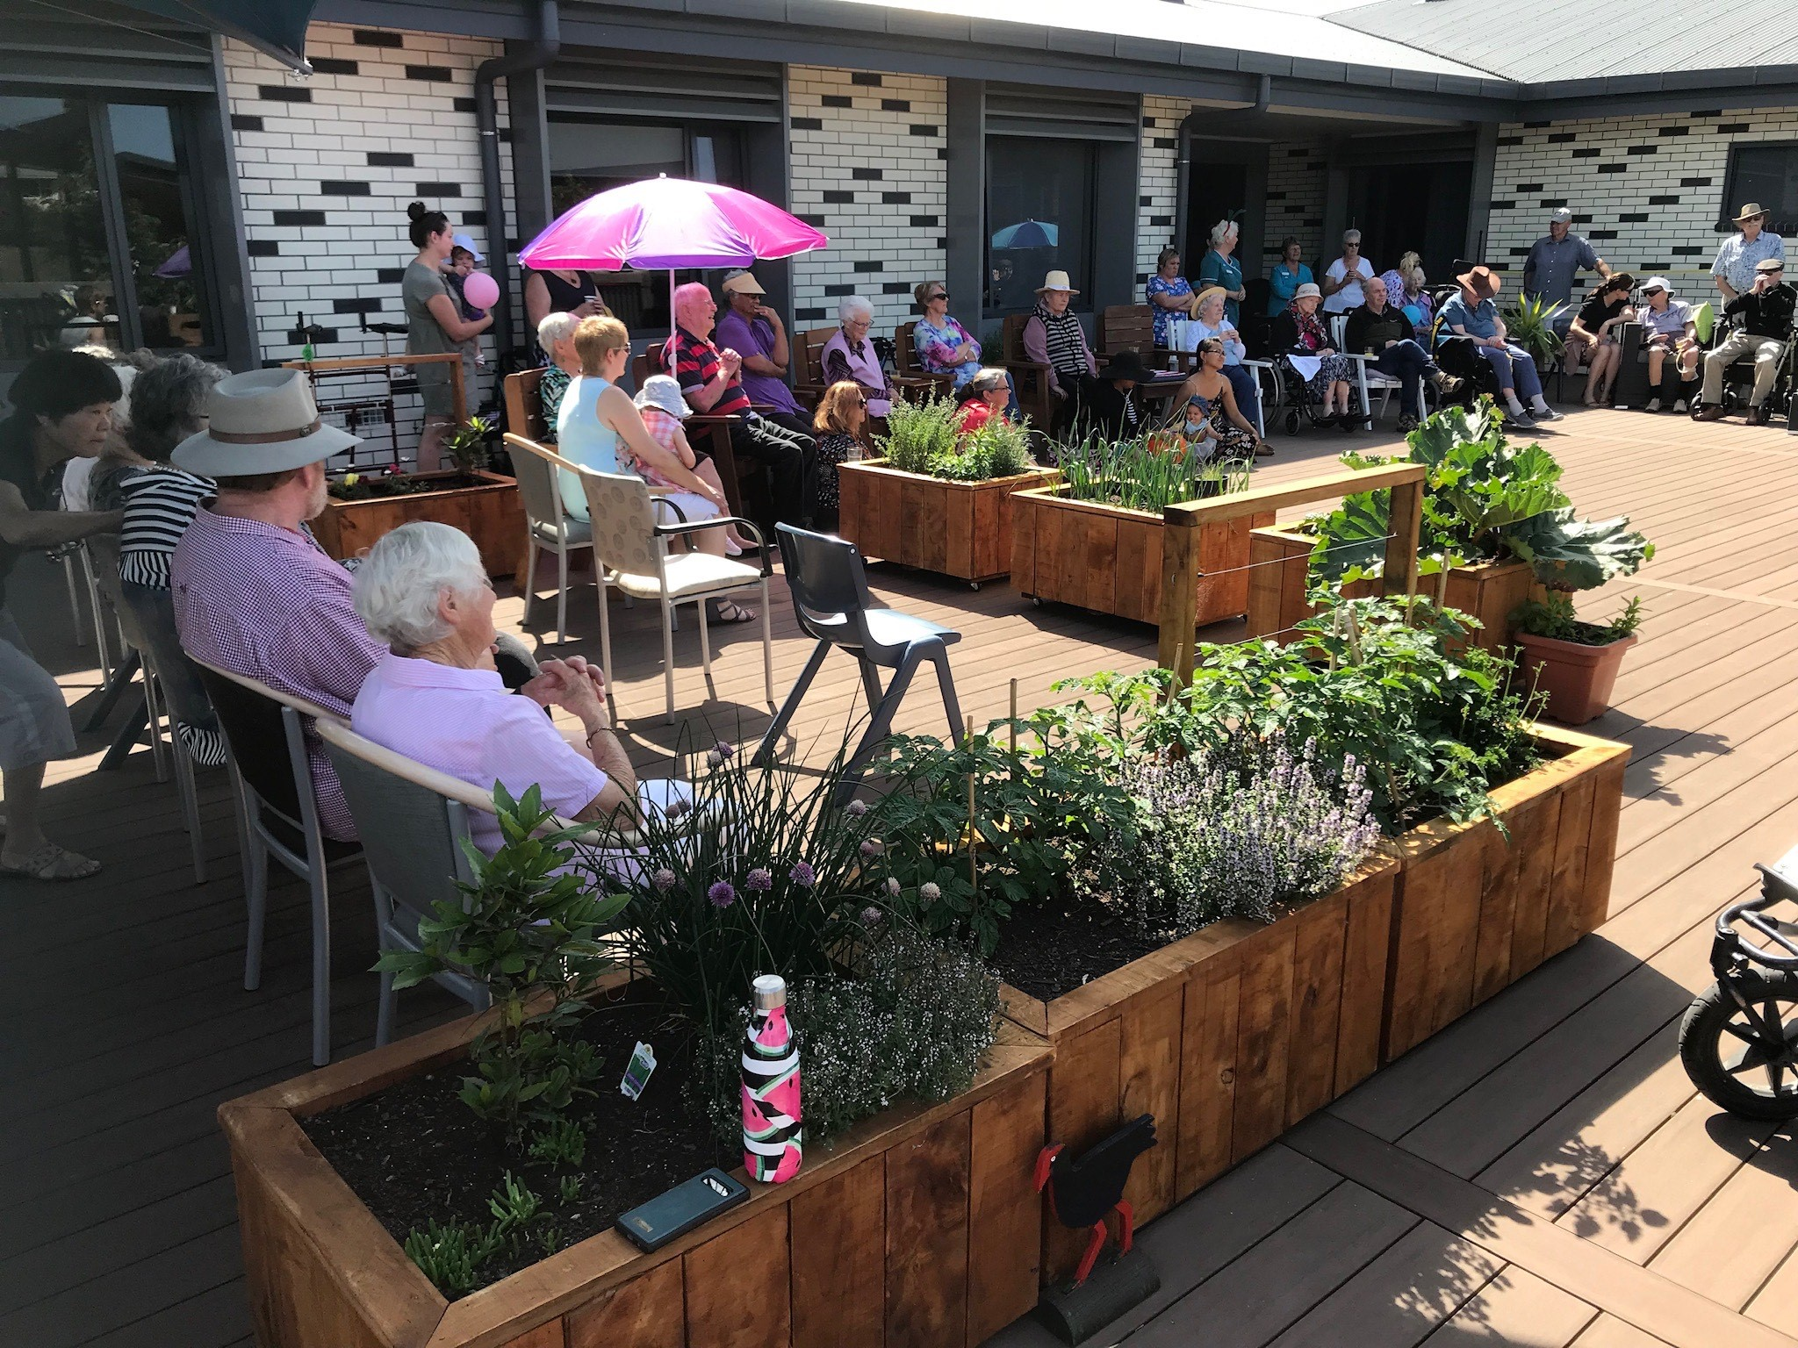

Kaikoura Lions
Kaikoura Lions made planter boxes for the Kaikoura hospital deck. A lovely place for patients and visitors to enjoy the atmosphere.
Convention Time is fun, new friends and learning about Lions, see you there.

Convention detail listed under Convention on Website.

President and members of Christchurch Host Lions Club
Warmly invite your club members
to the

60th anniversary

of the chartering of our club and
the start of Lions Clubs International in the South Island
at a

Luncheon
Sunday 16 February 2020
Balmerino Room Riccarton Racecourse
Christchurch
11.30am for 12.30 pm
$40 ticket
RSVP
Reserve your seat NOW
By 15 December 2019.
miles.ellery@actrix.co.nz

Confirm your seat with payment by direct credit by 6 February 2020
bank account- 03 0823 0096314 000 with your name and club as reference
or
Mail cheque to Christchurch Host Lions Club, Secretary PDG Miles Ellery, PO Box 31-032, Ilam, Christchurch, 8444

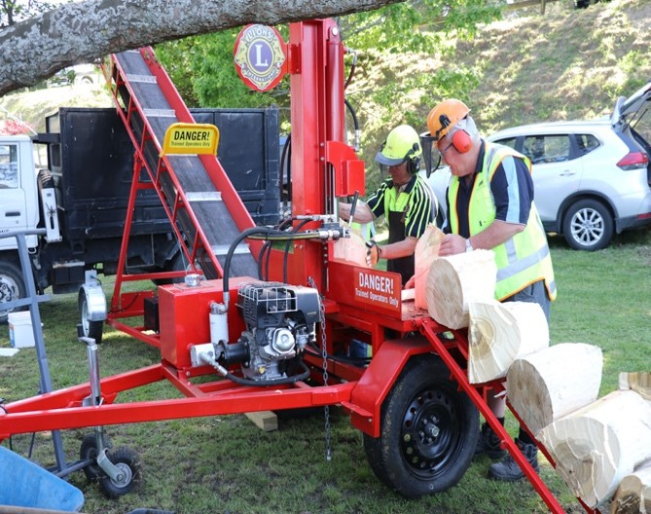
Amberley
At the A & P Show the splitter and loader were
working just about full time, processing the
chopped logs donated to us from the competition
events. We sold and delivered 2 full truckloads on the
day (6 cubic metres each load) and another load
the next day.

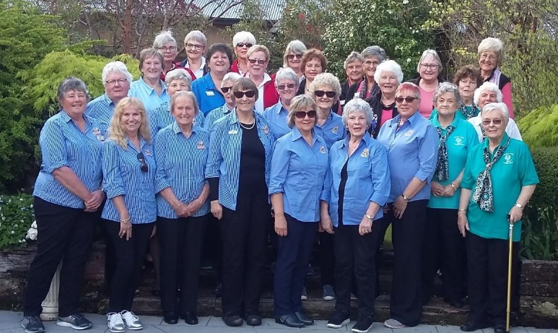
Lioness Forum
Photo taken at the forum of all the gorgeous Lionesses from Motueka (blue left), Nelson (blue middle), Haven (green right), Geraldine (red back) and Rangiora (peach back)
Report from President Jillian Gary Lioness Club of Nelson.
Lionesses from Nelson, Motueka, Rangiora and Geraldine gathered for their annual forum at Hamner Springs where we renewed and made new friendships and learnt a little more about the Lioness Bridge Program. Council Chair Helen Williams delivered the message from Lions International about our imminent demise as Lioness clubs and provided a platform for us to raise questions that weren’t covered in the information available to date. Clubs are in the process of digesting this information, waiting for the answers to our questions and finding the path to be journeyed by their members.
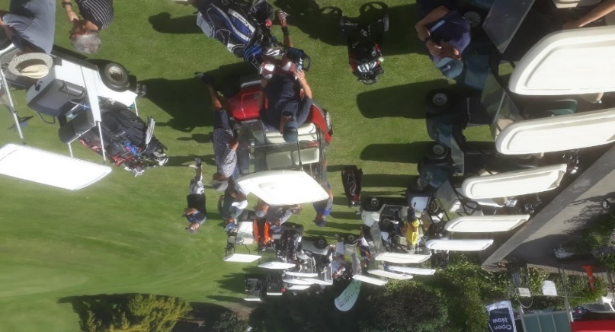
Akaroa & Bays
A very sucessful Golf tournament held and the proceeds presented to the excited Duvauchelle Plunket Preschool.

Convention Time is fun, new friends and learning about Lions, see you there.
LIONS CLUB of WOODEND WAR MEMORIAL PROJECT
The Lions Club of Woodend are excited to report that construction of the memorial is almost complete and wish to acknowledge the efforts of our contractor, Peter Dunn of Dunn’s Stonemasonry of Rangiora, and the Waimakariri District Council. It is indeed special to see the memorial take shape and we trust it will be well received and embraced by the community of Woodend and surrounding districts.
We also wish to acknowledge the financial support we have received from the community and funding sources, which has made this project possible.
An Unveiling and Dedication ceremony is planned for Sunday 8 December 2019 and details are attached. We would hope to have a good community presence for this occasion.
Ian Lennie President Woodend Lions

Artist’s impression
The Unveiling and Dedication
of the Woodend War Memorial
Will take place at the Memorial, adjacent to the Woodend Community Centre, School Road, Woodend
Sunday 8th of December 2019
at 11:00am
All public are invited to attend

The Royal Visit to Kaikoura 23rd November 2019
Businesses , clubs etc were invited to showcase their business and projects. Seaward Lions displayed some of their Trash Fashion costumes. It was a big day for Kaikoura and Prince Charles enjoyed the chat with Lions and many others.
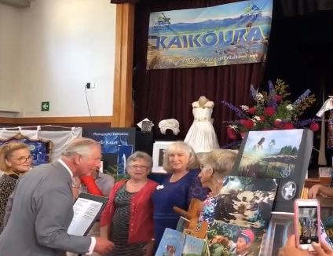
Prince Charles talking to Seaward Lions Members and the display of costumes
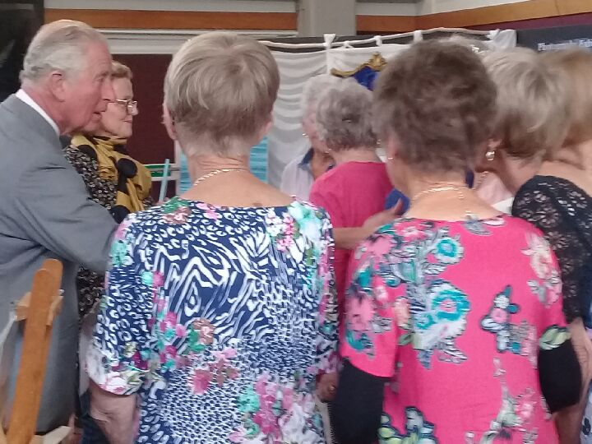
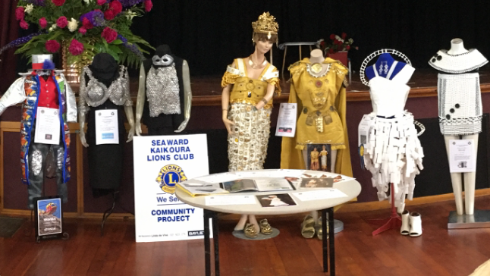

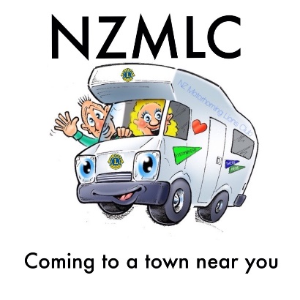
NZ MOTORHOMING LIONS CLUB
After a few hiccups and delays I am happy to announce that the NZ Motorhoming Lions Club can now formerly operate as a branch club of the Lions Club of Blenheim. I am delighted that Past District Governor Malcolm is to be our Lion Liaison, and I am very much looking forward to working with him on this exciting project.
To date I have received 4 formal applications for membership - with myself being the 5th member. The applications have come from 2 former Lions in Auckland, a resigned member from Ashburton Pakeke - who we are hoping we can reinstate; and my partner, George Shepherd.
Over the last few months George and I have been travelling around the South Island and have been promoting the Club wherever and whenever possible. One couple that I met are very keen - they are past DG’s for their District and like me, they want to travel but not give up their life as a Lion. Now that I can tell them that we are officially a branch, I feel confident that they will come on board.
Since July I have had major issues with the email for the Club. This has finally been resolved after many headaches and phone calls. This in itself was a major holdup getting information to people as I didn’t have hard copies of interested parties details with me during our travels as we have to travel light.
So where to from here?
Again next year the NZMLC will have a presence at the South Island Motorhome Show, hosted by the Ashburton Lions Club. This is being held over the weekend of February 29th at the Ashburton Showgrounds. Thankfully it won’t be a one man band this time around as I will have both George and Meredith to assist. They don’t know it yet!!
The following weekend is the National NZMCA (NZ Motor Caravan Association) rally in Oamaru.
George and I will be attending this as members of the NZMCA, however I have approached them and asked whether we might have a site to promote the new Club. They had a meeting recently but at this stage my request is yet to be responded to.
Onward and upward.
Tracy Henderson NZ Motorhoming Lions Club Ph: 021 352 754

A Thank You To Our Incredible Volunteer Fire Brigades from the Lions and Lionesses in the Top Of The South
A total of 354 Cakes in total will be distributed
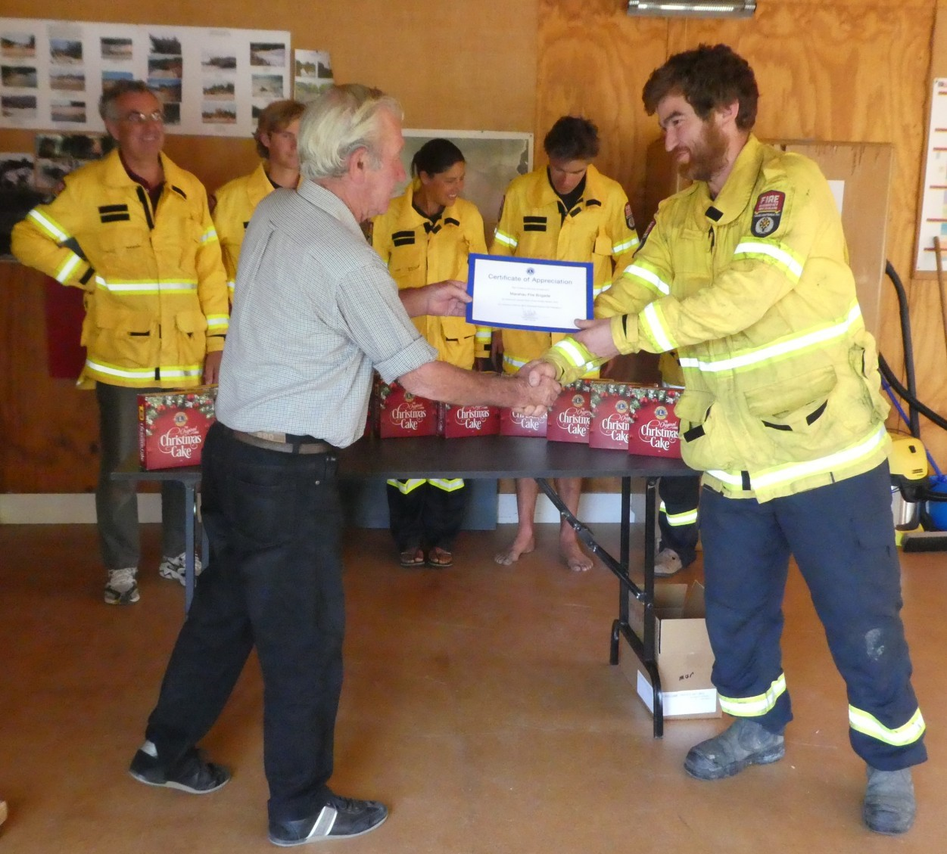
to firemen & women in the next few weeks before Christmas Christmas, by Lions & Lionesses in Zone 2. Showing how much we all recognise the fantastic job that they they carry out on call 24 hours a day, 7 days a week .

LIONS CLUBS INTERNATIONAL DISTRICT 202E
DISTRICT CONVENTION –Rangiora
NOMINATIONS FOR DISTRICT GOVERNOR, 1st and 2ND VICE DISTRICT GOVERNOR AND DISTRICT 202E CHARITABLE TRUST 5th TRUSTEE (2-year term)
REMITS, CLUB DELEGATES, DECEASED LIONS VALEDICTORIES
Nominations and Remits for the 2020 Convention must be in the hands of the Cabinet Secretary 60 days prior to the Convention, that is by 6th January 2020.
If your Club is submitting a remit, please study the International Constitution to assist you in drafting the remit.
Attached are the nomination forms, registration form for Club Delegates, and Valedictory form.
Clubs are entitled to one delegate from their Club for every ten financial member at 1st February 2020. Club members must have been a member of Lions International for a minimum of one year and one day to qualify as a club member. The major fraction shall be five (5) or more members.
Many Clubs, unfortunately, have had members pass away since last convention. It is important that these members be remembered at the Convention Rededication Ceremony. Please write a Valedictory for these members, covering their Lions history including the highest position reached in Lions. These will be read at the Rededication Ceremony and must be received by the Cabinet Secretary no later than 7th February 2020.
Yours Sincerely, Ian Cameron District 202E Cabinet Secretary 5 Inglis Street, HAVELOCK 7100 Email ianc.cameron@xtra.co.nz

LCIF PDG John Benefield
Club contributions to Campaign 100 and the Australia Bush Fires are being deposited in the LCIF (Lions Clubs International Foundation) International Account and these all qualify for Melvin Jones Fellow Credits for the Club.
DG John’s goal is for 100% of clubs in this District to contribute to LCIF Campaign 100 this Lions year. Encourage your club to donate to this cause as without support LCIF cannot continue the work with Diabetes, Childhood Cancer, Youth, Sight, Environment, Humanitarian, Measles to name a few.
All Club coordinators have been sent a PowerPoint presentation of the latest work of your Foundation and the Campaign 100 progress to date. Do you know what Campaign 100 is about? Ask your club to have your Club coordinator to present this information to your club.
I am available to visit clubs to talk about the Foundation’s efforts around the world and in NZ. A recent visit to Havelock which was also attended by 4 visiting clubs opened member’s eyes to the achievements of LCIF.
Thanks to the selfless sacrifice and dedication of thousands of Lions, LCIF has been able to grant more than NZ $1.7 billion to Lions service projects and partnerships around the world. The generosity of the Lions community has allowed LCIF to give sight, to support youth, to provide disaster relief, and to address a wide range of humanitarian needs.
Some may ask, why should we give to LCIF? We already support other causes. It’s important to remember that the foundation empowers service. Individually, we serve with our clubs and make differences in our local communities. LCIF allows us to extend and magnify that impact on a global scale.
LCIF is your foundation. It belongs to every Lion, and empowers the service and impact of Lions everywhere. The success of LCIF is truly the success of our global community of Lions.

Did you know?
- NZ $183 million granted towards disaster relief
- 16 million children and youth served by Lions Quest
- Through two successful campaigns, invested NZ $646 million in SightFirst
- Provided measles vaccinations for more than 87 million children
- Improved or restored sight to 30 million people

- NZ $53,878,349 Grant Dollars Awarded in 2018-2019
  - SightFirst Grants 9 Grants Approved NZ $18,436,717
  - Humanitarian Grants 225 Grants Approved NZ $30,856,037
  - Lions Quest Grants 44 Grants Approved NZ $1,216,657
  - Diabetes Grants 28 Grants Approved NZ $3,136,939
Last year LCIF awarded over NZ $53 million in grants to all our constitutional areas. This was made possible by Lions and clubs like you and yours!
Has your club been assisted by family members and friends on projects?
Consider purchasing a LCIF 2019-20 Bronze, Silver or Gold pin as a thank you. You may need their help again in the future.

Deadline for bulletin – have your report, photos etc to me by 20th of the month

Hope you read and enjoy the bulletin as it takes some hours to put together.
If you have any suggestions please let me know.

To help me with the District Diary, it would make it easier for me if you emailed to let me know as it is your bulletin not mine. I put the bits together that I receive from you. Keep them coming in.
me the dates of special events.
By the way I do not receive all club bulletins, would be good to get some other club projects in the bulletin.
PDG Julie Syme QSM
Editor

Melville & I send our warmest greetings to you all for Christmas & New Year wherever you may be. Be safe and be energised for the next half of the Lions year.
Next Bulletin in January 2020

