Incident / Accident
Report & Learning Team Form

This form must be completed with corrective actions and Presidents comments before returning it to the
Health and Safety Co-ordinator, within 72 hours.

** In the case of Serious Harm or possible Serious Harm, please follow the Notifiable Incident Resource

1. Person Involved:

Name:

Contact No:

Member: Non-member: :

2. Details of near hit / incident / accident:

Location:

Date: Time: am / pm

3. Severity:

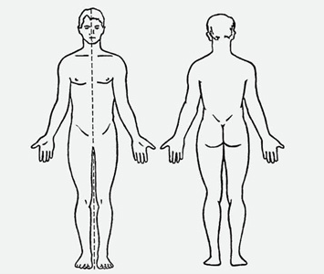
No harm near hit Minor Harm Serious Harm Fatal

Please indicate on drawing part of body affected

4. Treatment:

Nil First Aid Doctor Hospital

5. Description of what happened:

THIS IS ALL THE INFORMATION REQUIRED NOW

6. Describe the cause of the near hit / incident / accident:

Contributory Factors (refer to these when identifying the cause of the near miss / incident / accident)

Immediate Causes Substandard Acts
- Guarding - Operating without authority
- Defective tools or equipment - Disabling safety devices
- Hazardous arrangements - Using unsafe equipment
- Unsafe conditions - Non-use of Personal Protective Equipment
- Unsafe design - Non-use of lock out / isolation systems
- Housekeeping - Unsafe positioning
- Environmental conditions - Distraction / fooling about

Please complete the other side of this form

7. Has a significant hazard been identified? Y / N

If yes, please record this hazard and update the event plan accordingly

8. Chance of the near hit, incident or accident recurring:

One off Daily Weekly Monthly 6 Monthly +

9. Corrective Action: (What will be done to minimise the risk of this happening again)

Action By Whom Completed

10. Presidents Comments:

Signed:

Date:

11. MD Coordinators comments:

Date:

12. All corrective actions completed:

Signed: Date:

Retain a copy on club file

