Memorial Funeral Patches are available from

The Lions Club of Rongotea & Districts

Contact:  Ashley (Ash) Hazlitt (Pauline)  Email: a.p.hazlitt@xtra.co.nz | 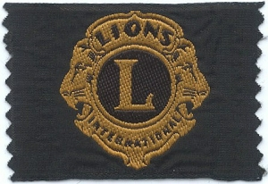

Money Raised Goes to The Lloyd Morgan Lions Clubs Charitable Trust

$25 per packet of 50 Emblems

(invoice will be sent with order)

